

Morice Town Primary Academy

SEND Information Report 2026

Our School | Morice Town Academy are a warm and friendly school that welcomes visitors and actively encourages a partnership with parents. We strive to provide a high quality creative and engaging education within a caring and happy environment where our children thrive. Learning takes place in a caring and happy environment; we want our pupils to be confident, happy and caring individuals leading to them becoming successful and responsible members of our school community.  We believe that education is a lifelong process and that whatever children learn here with us will form the building blocks for the rest of their lives. We have designed a relevant and progressive curriculum ensuring that:  All pupils will leave Morice Town Primary and Drake Academies with the skills and knowledge to know ‘who they are and where they are in the world’. They will have a sense of place and purpose to thrive in a multicultural, diverse society.
  Meet our  Inclusion  Team | Our SENDCo is Hannah Bennett.  Mrs Bennett has a wealth of experience both teaching and supporting children and young people with SEND, she has the NASENDCo qualification and numerous qualifications in SEND including Trauma Informed training, STORM training, mental health support and specific Autism training.  Mrs Bennett works closely with Mrs Bywater, our parent support advisor and Mrs Brown, our speech and language therapist.  The SEND team can be contacted through the school office 01752 567609 or email hannah.bennett@moricetownacademy.org
  Special  Educational Needs | At Morice Town Primary Academy we support children with a variety of differing special educational needs and we pride ourselves on being a highly inclusive school with an ethos which encourages and celebrates diversity and difference.  SEND is categorised into the following areas in the SEN code of practise 2014:  It is possible for children to have more than one area of need.
   | Cognition and Learning  this is where a pupil is learning at a significantly slower pace than others in their year group
   | Communication and Interaction  this includes speech and language as well as social communication difficulties which includes pupils on  the Autism spectrum
   | Social, Emotional and Mental Health this includes pupils with challenging behaviours, anxiety, ADD, ADHD, or attachment disorders
   | Sensory and Physical  this includes hearing difficulties, visual difficulties, mobility difficulties and sensory processing problems

  Identifying and Assessing  Need | At Morice Town Primary Academy if staff have a concern about a child we will discuss concerns as a team, the inclusion team will then look into these concerns through discussion and observation and will meet with parents. A child will then be placed on the monitoring register and we begin to follow the Graduated Response approach of ‘Assess, Plan, Do and Review’.  We will then decide if a child needs to be placed on the SEND register and invite you in for a meeting, where we will share the targets your child is working on and the support they are receiving.  Some children may require more support than is ordinarily available and we may ask outside agencies to support us in ensuring that we are offering the best support we can.  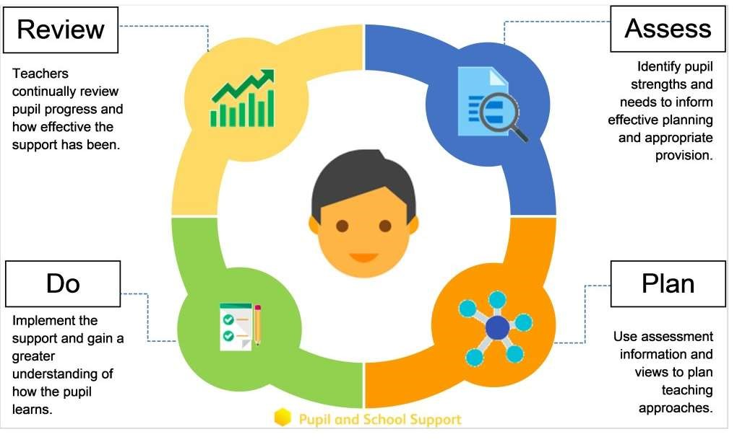
  What to do if you think your  child has SEND | Speak to the class teacher about any concerns.  Teacher discusses concerns with the Inclusion Team (SENDCo).  Child added to Monitoring Register; Graduated Response begins (Assess–Plan– Do–Review).  Review meeting with parents to discuss findings and next steps.  Additional support/interventions put in place as needed.  External agencies involved with parent consent.  Term-by-term reviews and updates to targets.

If significant needs persist, school or parent may request an EHCP assessment.

Ongoing collaboration between parents, teachers, and the SEND team

  Our approach to teaching  children with  SEND | We are an inclusive school. Wherever possible children are taught alongside their peers in flexible teaching groups.  Teachers adapt their high-quality teaching to cater for their pupils’ needs and plan individual timetables where necessary. When appropriate, staff are deployed to give children additional interventions in small groups outside the classroom, or to provide one-to-one support.
  Curriculum adaptations | We use a range of strategies across our lessons to ensure we offer an inclusive approach to learning and allow all children to access the classroom environment.  These may include…  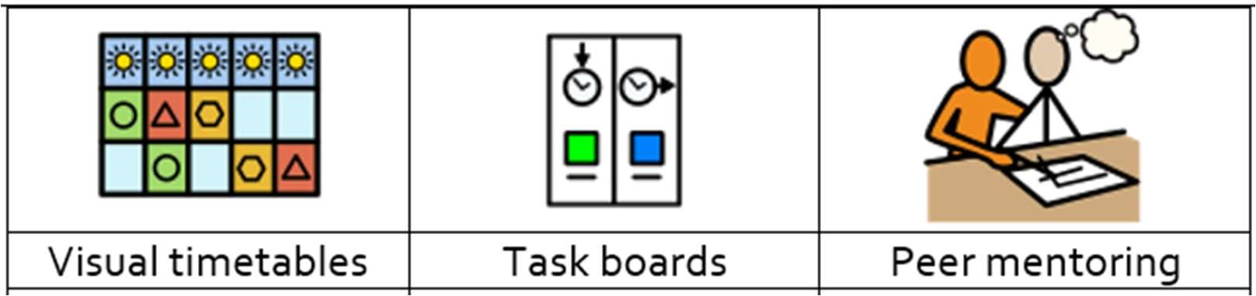  We also seek advice and equipment from outside agencies as and when the need arises.

 |  |  |  | 
 |  | Assistive technology | Talk partners | Peer marking
 |  |  |  | 
 |  | Self-assessment | Word banks | Positive behaviour
 |  |  |  | 
 |  | Ear defenders | Timers | Explicit instruction
In-School  Support for SEND | Morice Town Academy provides a wide range of high-quality in-school support for pupils with special educational needs. Our commissioned Speech and Language Therapist works in school one day a week to assess children, deliver targeted 1:1 or small-group therapy, and support staff and parents in meeting children’s speech, language and communication needs.  Alongside this, our trained starfish team offers emotional literacy support to help children build confidence, resilience and social-emotional skills. We work closely  with MAST who provide us with Educational psychologists, family support workers and learning mentors. This joined-up, collaborative approach ensures that pupils receive the specialist and nurturing support they need to thrive.

  Parent  Consultations | At Morice Town Primary Academy we work closely with parents and carers and recognise that they have much to contribute to our support for children with SEND.  We hold meetings at the end of the Autumn and Spring terms with parents and carers to discuss progress and engagement in class. Pupil learning plans are also shared with parents during these meetings for children on the SEND register. We also share reports in the Summer term. Class teachers can be contacted at any time if there are any issues or concerns, teachers emails can be found on the year groups pages of the school website.  For those children who have an Education Health and Care Plan meetings with parents and other professionals are planned at least annually in addition to the parent consultations. These reviews are led by the SENDCo.
  Child  Consultations | Pupil’s views are very important; they have a right to be involved in decisions about their education and they are made aware of the support that surrounds them in school.  Children are fully involved and their views feed directly into all policies, procedures and daily teaching of all children.  Pupils are given regular opportunities to:  through involvement in pupil groups such as the School Council, Eco Warriors and Reading Ambassadors pupils are also involved in decision making for the wider school community.
   |  | 
  Self-assess how they are doing | Attend meetings and help decide the support needed. | Feedback and Review progress/interventions.
 | Evaluation of the provision for our pupils can be completed in a variety of ways, including:  • Review progress in SLT meetings and fortnightly year group meetings and discussing next steps.

Evaluating Provision | - Discuss and share ideas in staff meetings to ensure up to date research and policy is in place.  - Reviewing children’s individual progress towards their goals at regular intervals, as a minimum every term.  - Establishing children’s baseline before receiving interventions and reviewing the impact of interventions at regular intervals.  - Asking our children if they feel the adjustment or intervention is helpful and makes a difference.  • Monitoring by the SEND team.  • Regularly update targets and measure progress.  - Holding termly reviews for children who are on Education Health and Care Plans, SEND Support Provision Plans and those requiring specialist support.  - Holding annual reviews for children with Education Health Care Plans.
  Staff Training | At Morice Town Primary Academy, we believe learning is a lifelong commitment for us all and aim to ensure all our staff have the understanding they need to enable them to support your child.  When a new member of staff joins the school, we ensure they understand the systems within school and they are given information about the children they are working with.  The senior leadership team within school are constantly moderating needs and, where an area of concern is highlighted, whole school training could be organised to ensure all staff understand specific learning difficulties and appropriate teaching or support strategies that could be utilised.  If your child needs specialist support from an outside agency, such as the Speech and Language Service (SALT), Educational Psychologist (EP), Visual or Hearing Impairment Team or school nurse, we will always discuss this with you first.  Some of our staff have completed training in the following areas. When staff go on a course, they have an opportunity to give feedback to the rest of the staff during staff meeting sessions.  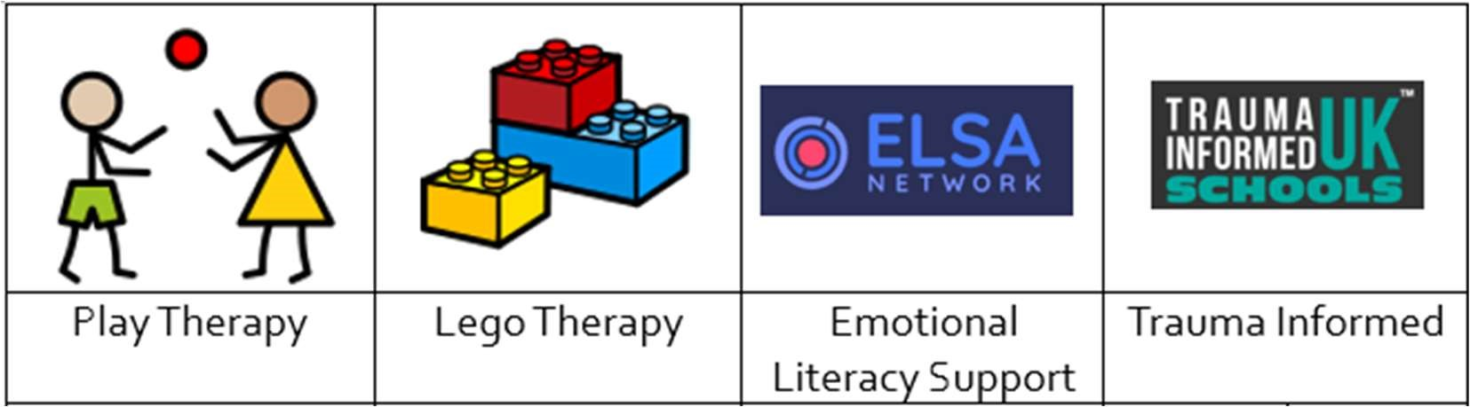

 | 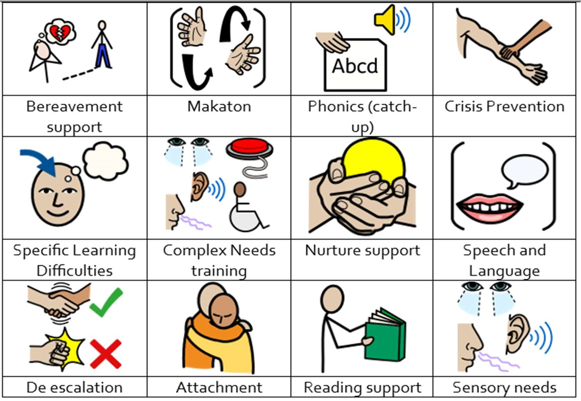
  Transition  Support | Nursery to Reception  We hold a parent and carer session in the summer term for our new reception starters, providing parents with the opportunity to meet with the class teacher and SENCO.  Transition to Reception, and then into each successive year-group, is supported by meetings, information leaflets and taster sessions in each new class.  End of Year transition  When children move up a year, we provide transition sheets which include photos of the teacher, TA and classroom environment.  We hold transition sessions during the summer term allowing the children to go up to their new classroom and meet their teacher.  Some children may require extra transition visits to their new classroom to help reduce their anxiety and ensure that the transition is successful and positive.  Class teachers and TAs meet with each other during the summer term to discuss the needs of the children and share information.  Secondary Transition  We liaise very closely with our partner schools to ensure that the transition from primary school to the secondary school is as smooth as possible.  Mid-Year new starters  When we are aware that pupils joining us from other settings have identified special educational needs, we arrange a meeting with the family and previous settings to enable us to gain a greater understanding on the support we need to put in place.
  Outside  Agencies | We work with multiple agencies to provide support for children with SEND this may include:  MAST – Multi Agency Support Team  CIT – Communications and Interactions Team  Educational Psychologists  PIASS – Plymouth Information and Advice Support Service  School Nursing Team  CAMHS – Child and Adolescent Mental Health Service  We will ask your permission before we arrange for any outside agencies to come in and work with your child.
  Clubs and  Trips | All our extra-curricular activities and school visits are available to all our children.  All children are encouraged to  - go on our trips such as day trips and residential stays in Key Stage two.  - take part in sports day, school competitions, school assemblies and performances, workshops, etc.  - apply for roles of responsibility in school e.g. school council, playground buddies, eco-warriors and reading buddies.  No child is ever excluded from taking part in these activities because of their SEN or disability.  Please read the school’s accessibility plan for further information about the steps we have taken to prevent disabled children from being treated less favourably than other children and the arrangements we have made to help children with SEND access our school.
  Complaint Procedure | In the first instance please contact your child’s class teacher. If you are not satisfied that your concern has been addressed, then you may make an appointment to speak to the SENCo or Assistant Head. If they cannot solve your issue, then an appointment can be made to speak to the Headteacher.  Our school complaints procedure can be found on the school website.
  Plymouth  Local Offer | More information about Plymouth Local Authority’s Local Offer for children and young people with SEND and their families can be found on the Plymouth Online Directory  www.plymouthonlinedirectory.com  Further support for families and carers can be received from contacting PIASS https://www.plymouthias.org.uk/ or calling 01752 258933 there is also a national helpline 08009531131. PIASS can be emailed at pias@plymouth.gov.uk

