Year 3 - Unit 3 – The Bronze and Iron Age
This is your second unit that explores ancient civilisations after your work on the Stone Age earlier this year.
What we are learning:  LO: To develop a chronologically secure knowledge and understanding of British, local and world history - historical enquiry |  | What we are learning:  LO: To develop a chronologically secure knowledge and understanding of British, local and world history - similarities and differences |  | What we are learning:  LO: To develop a chronologically secure knowledge and understanding of British, local and world history - change and continuity |  | What we are learning:  LO: To develop a chronologically secure knowledge and understanding of British, local and world history - change and continuity |  | What we are learning:  LO: To develop a chronologically secure knowledge and understanding of British, local and world history - change and continuity |  | What we are learning:  LO: To develop a chronologically secure knowledge and understanding of British, local and world history - historical interpretations
  How we are learning/Small steps:  - I understand that events in time can be organised chronologically  - I can place key events onto a timeline |  | How we are learning/Small steps:  - I can explain similarities between the Bronze and Iron Age  - I can explain differences between the Bronze and Iron Age |  | How we are learning/Small steps:  - I can use historical sources to present information about life in settlements - hunting and food  - I can compare Iron age life to bronze age life |  | How we are learning/Small steps:  - I can use historical sources to present information about life in settlements - homes and shelter  - I can compare Iron age life to bronze age life |  | How we are learning/Small steps:  - I can use historical sources to present information about life in settlements - clothing and activities  - I can compare Iron age life to bronze age life |  | How we are learning/Small steps:  - I can form conclusions, using my research to support my ideas  - I can ‘prove it’ - When was the best time to be alive - the stone age, bronze age or iron age?
Key knowledge: |  | Key knowledge: |  | Key knowledge: |  | Key knowledge: |  | Key knowledge: |  | Key knowledge:
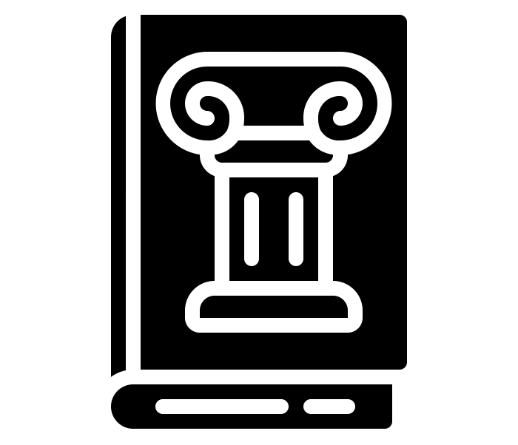 | A historian is someone who collects information about the past. | 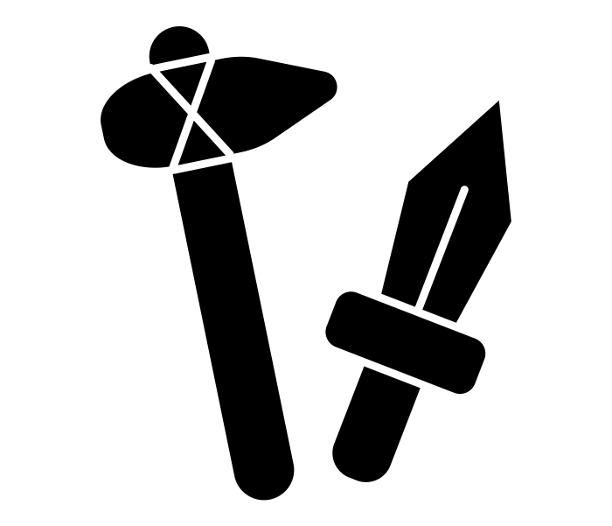 | The Bronze Age was the time from around 2,000 BC to 700 BC. Bronze was made by melting tin and copper, and mixing them. | 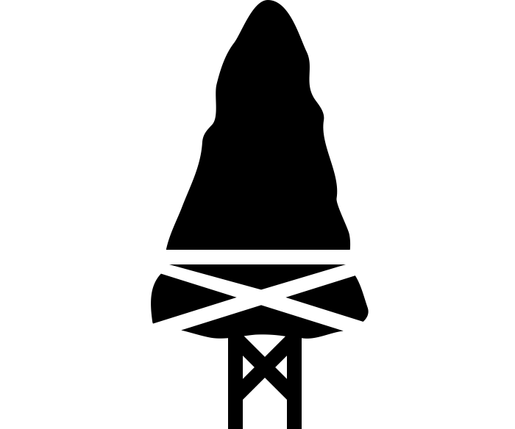 | Examples of bronze and iron arrowheads have been discovered in parts of Britain. | 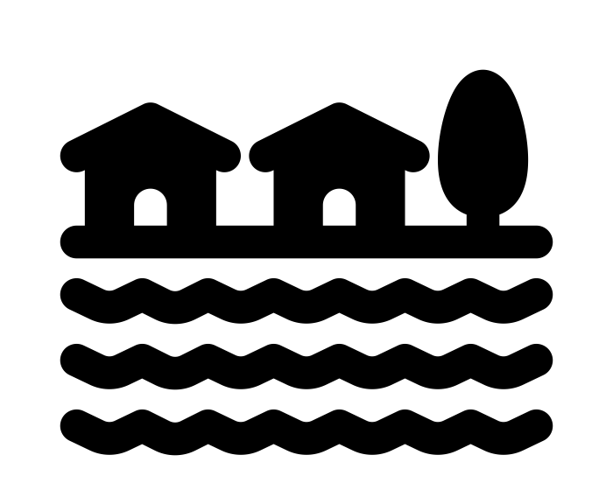 | A settlement is like a small village with groups of houses and farms. | 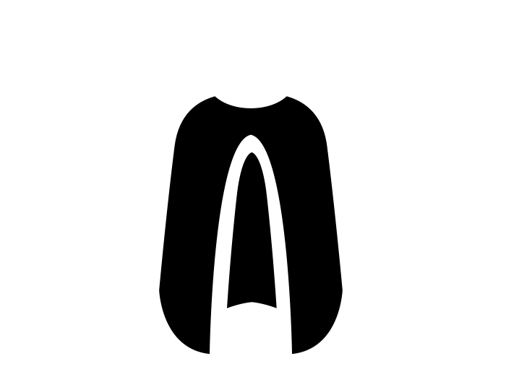 | Cloaks were made of materials such as wool and animal skin. We do not have artefacts as they would have rotted away over time. | 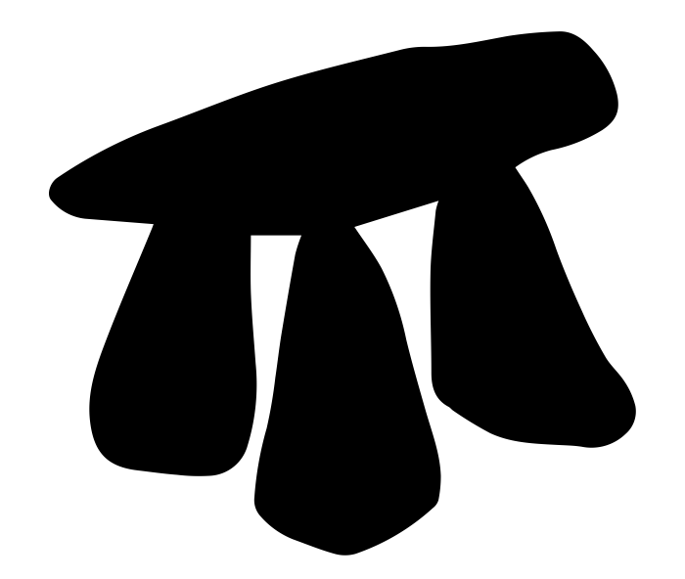 | There were exciting aspects of each period in prehistory.
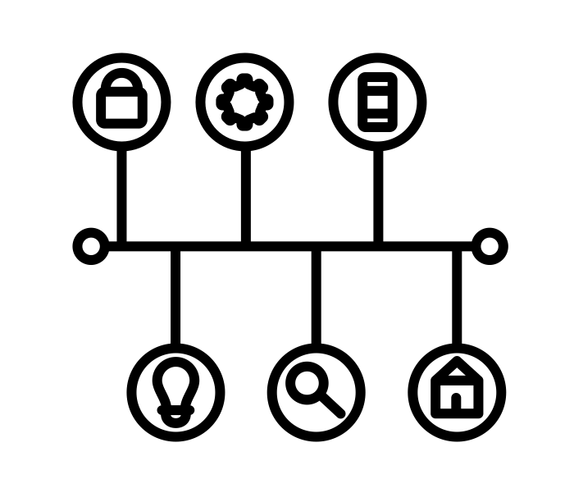 | Chronology means putting things in time order, from oldest to newest. | 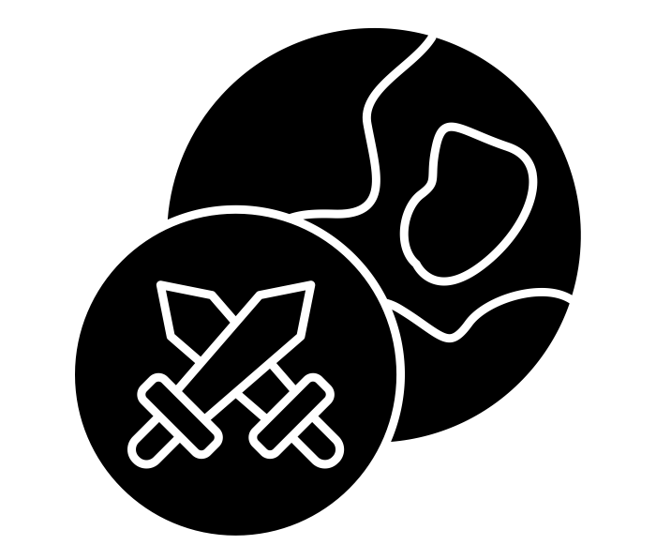 | The Iron Age began in about 800 BC and came to an end when the Romans invaded. During this period, people used iron and steel to make tools. | 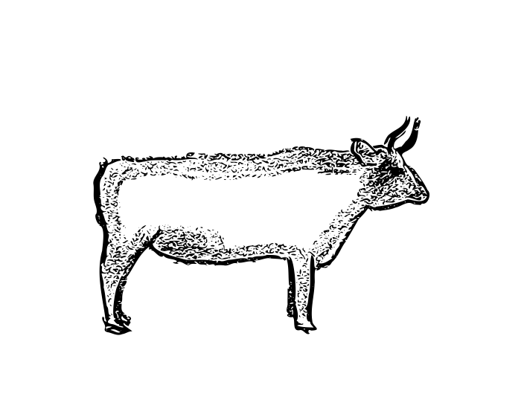 | Aurochs were large wild cattle that lived in Bronze age times. They are extinct now. | 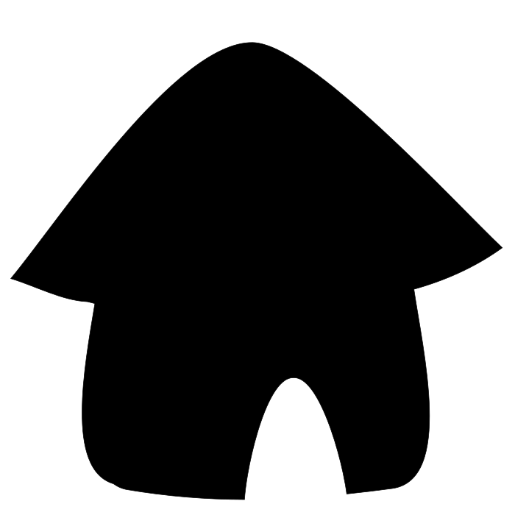 | A roundhouse is the name of the dwelling people used in Bronzer and iron age times. | 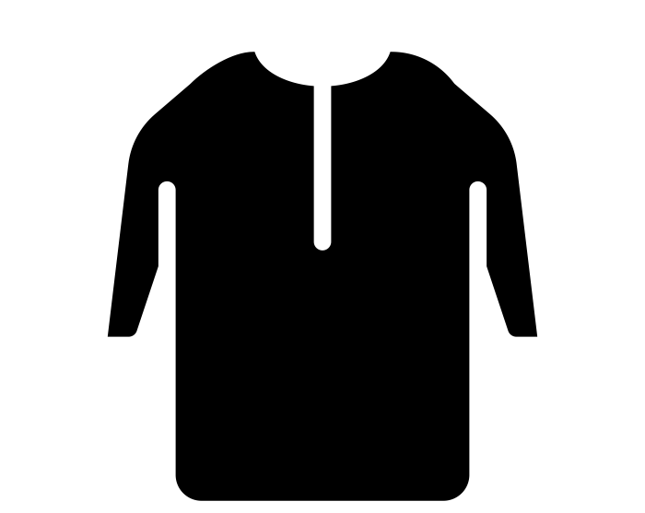 | Tunics were cloth garments that may have been woven. They were gathered at the waist and pinned. | 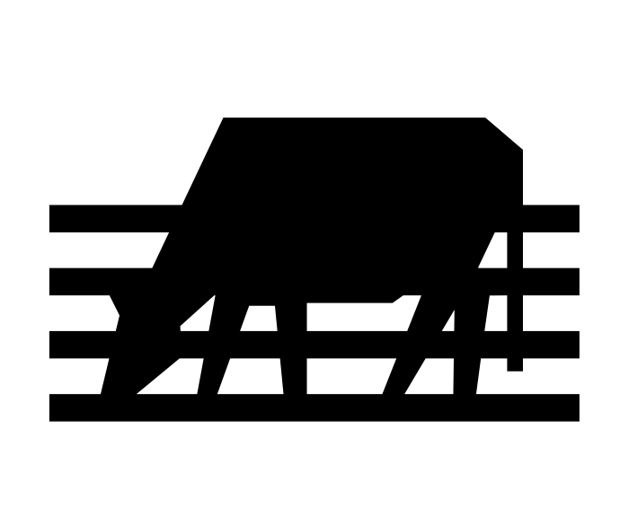 | Some inventions such as farming meant life changed and became more comfortable for people.
 | Prehistory is a time when there were no written records. We only know what happened from artefacts. | 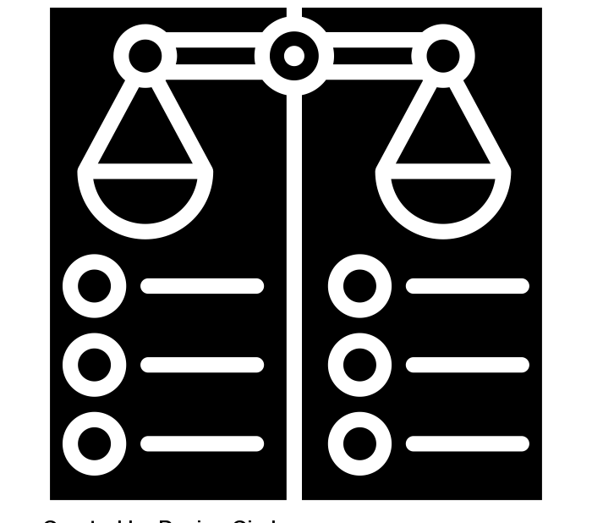 | When you compare two things, you look at them side by side and see what is the same and what is different. |  | As tools and weapons developed, so did farming. Paddocks (small fields) were made to keep animals close to the farm. |  | A roundhouse had a thatched roof and walls made of wattle and daub. | 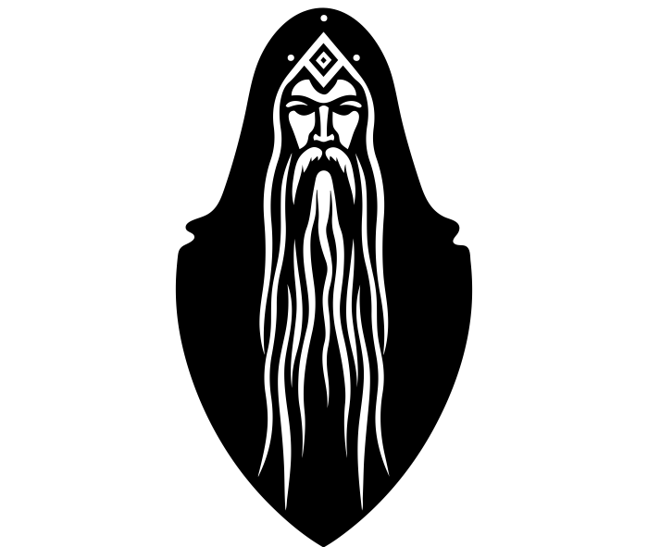 | A druid was a high-ranking person in ancient Celtic cultures. Druids were religious leaders as well as medical professionals and political advisors. |  | Some inventions such as metal weapons may have meant some periods were not as pleasant for people.
Key Vocabulary:  Historian  Chronology  Prehistory |  | Key Vocabulary:  Bronze Age  Iron Age  Compare |  | Key Vocabulary:  Arrowhead  Auroch  Paddock |  | Key Vocabulary:  Settlement  Roundhouse  Wattle and Daub |  | Key Vocabulary:  Cloak  Tunic  Druids |  | Key Vocabulary:  Conclusion  Research  Prove

You will learn about ancient civilisations again in Y4 when you study the Ancient Egyptians. If you are interested in this learning you may want to be a museum educator.

