Year 2 - Unit 3 – Food Journeys
You have completed lots of geography units but this is your first unit focusing on human and physical geography.
What we are learning:  LO: To identify hot and cold areas of the world in relation to the Equator and the North and South Poles |  | What we are learning:  LO: To use basic geographical vocabulary ot refer to key physical and human features |  | What we are learning:  LO: To use basic geographical vocabulary ot refer to key physical and human features |  | What we are learning:  LO: To use basic geographical vocabulary ot refer to key physical and human features |  | What we are learning:  LO:To identify seasonal and daily weather patterns in the UK |  | What we are learning:  LO: Tuse simple fieldwork and observational skills to study the geography of their school and its grounds and the key human and physical features of its surrounding environment
  How we are learning/Small steps:  - I can ask geographical questions about my world  - I can use fieldwork and research to answer questions |  | How we are learning/Small steps:  - I can name some physical features needed to grow food  - I can name some human features needed to grow food |  | How we are learning/Small steps:  - I can explain how weather affects how food grows  - I know that food grows well in some areas but not in others |  | How we are learning/Small steps:  - I can find the origins of a range of food  - I can identify their place or origin on a map and explain the conditions needed to grow the food |  | How we are learning/Small steps:  - I can find the origins of food grown in the UK  - I can explain how the weather and seasons of the UK affects how produce grows |  | How we are learning/Small steps:  - I can form conclusions, using my learning to support my ideas  - I can ‘prove it’ - Nothing tasty grows in the UK
Key knowledge: |  | Key knowledge: |  | Key knowledge: |  | Key knowledge: |  | Key knowledge: |  | Key knowledge:
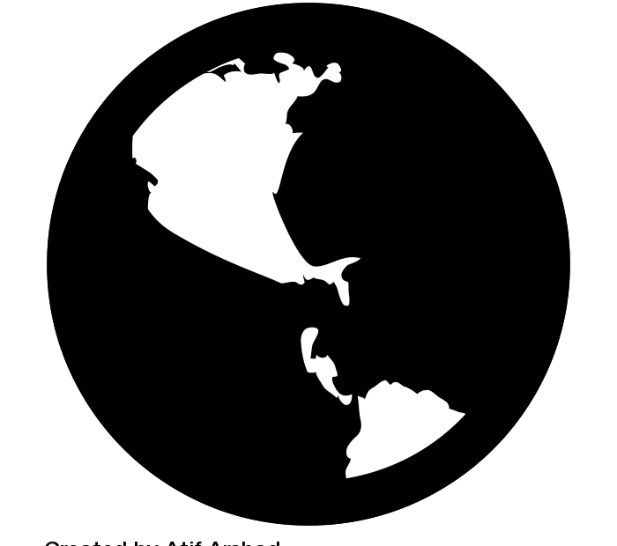 | There are different names for our planet. We call it Earth or ‘the world’. 3D maps of the Earth are allied ‘globes’. | 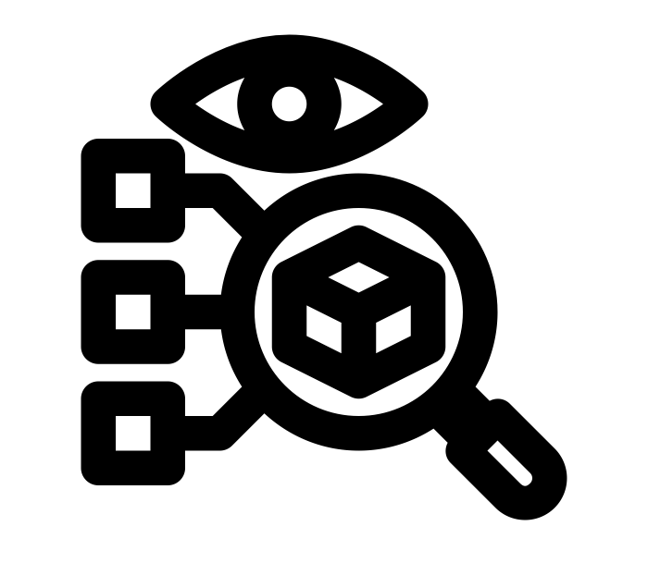 | A feature is a part of a place. They can be physical (natural) or human (manmade). | 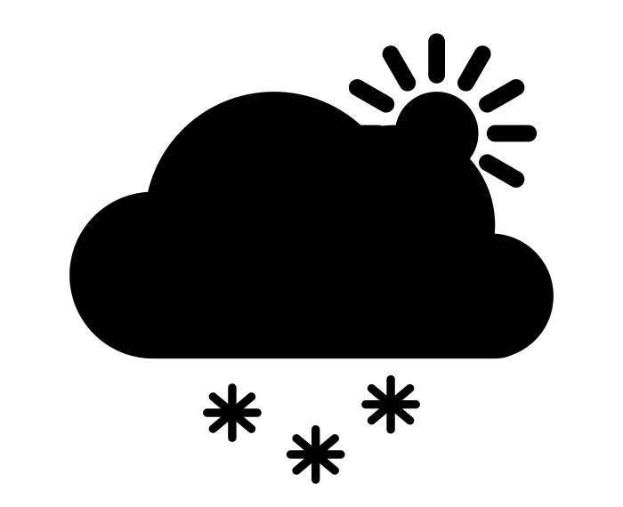 | The term weather describes the conditions outside; overcast, thundery etc. | 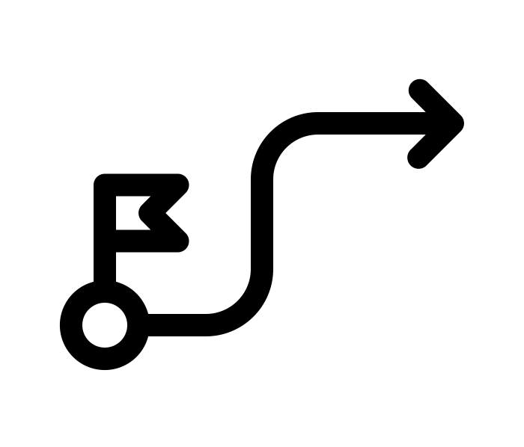 | Not all foods grow in the UK. Where a food is grown is called its ‘origin’. For some foods this could be thousands of miles away from the UK. | 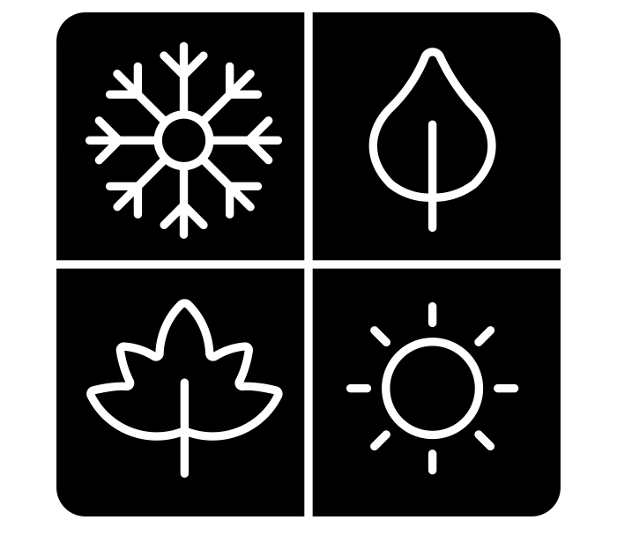 | Most plants grow in the spring. We usually harvest food in the autumn. Modern farming means we now grow food in all seasons. | 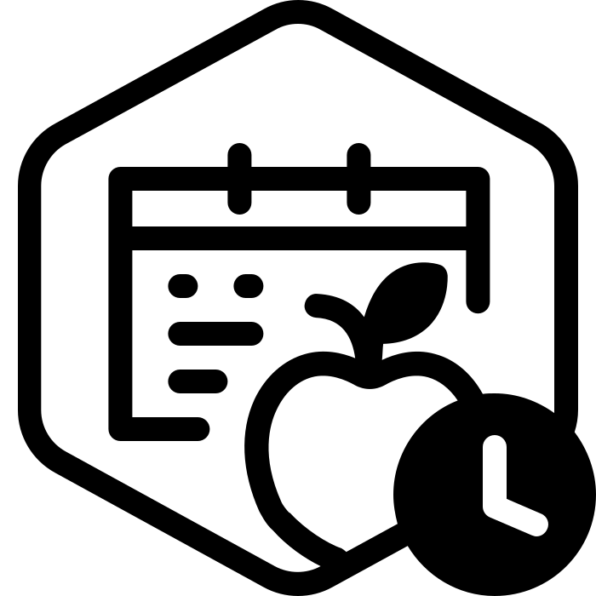 | Modern farms can grow anything anywhere but this can be expensive.
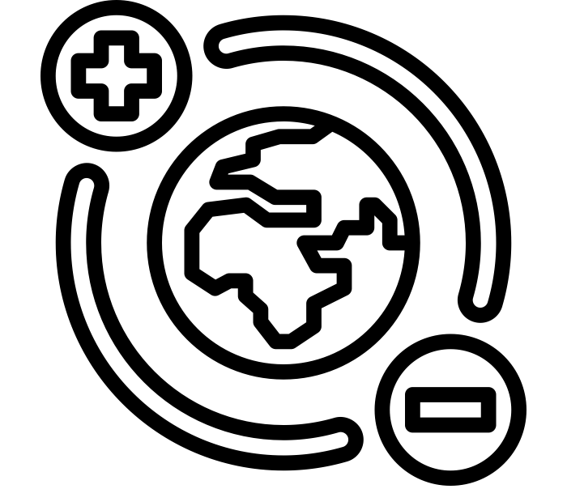 | At the top and bottom of our world are the North and South Poles. These are cold, icy, snowy places. | 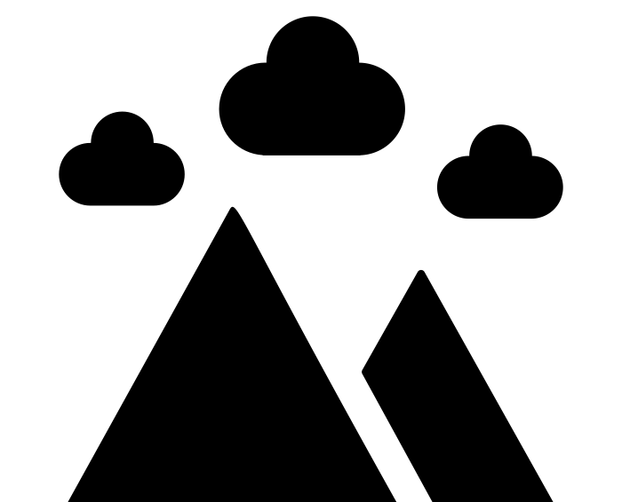 | Physical geography is what the land around an area is like. It refers to hills, lakes, parks etc. | 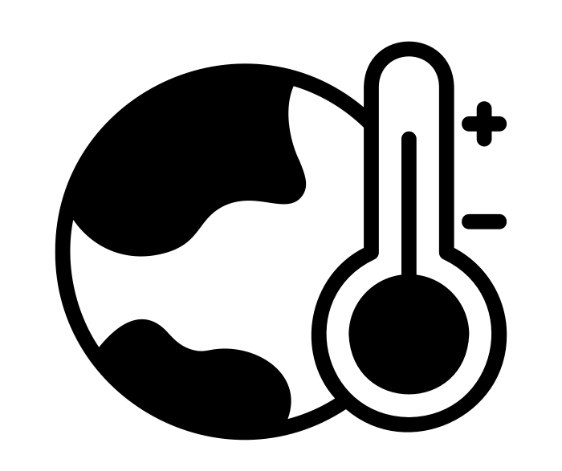 | The climate of the UK is temperate - this means it is warm in the summer and cold in the winter. | 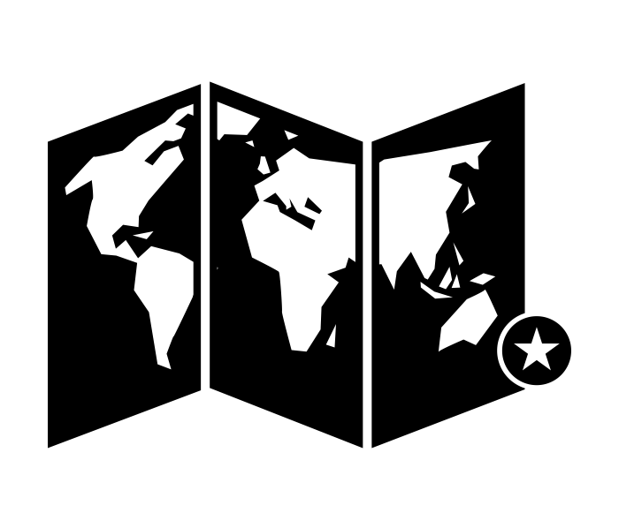 | There are different kinds of maps; paper maps, online maps and 3D maps (globes).They may show the world or just a small town. |  | When we buy seasonal foods, we buy it at the time of year when it grows. | 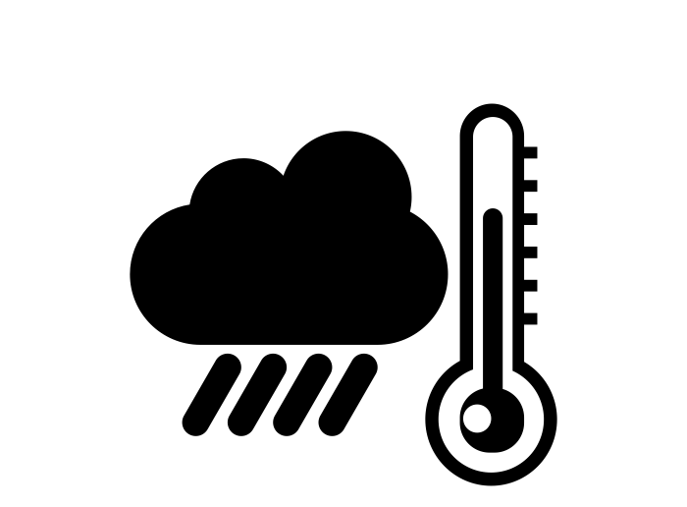 | Conditions in the UK are good for growing, but only for things like cabbages and wheat.
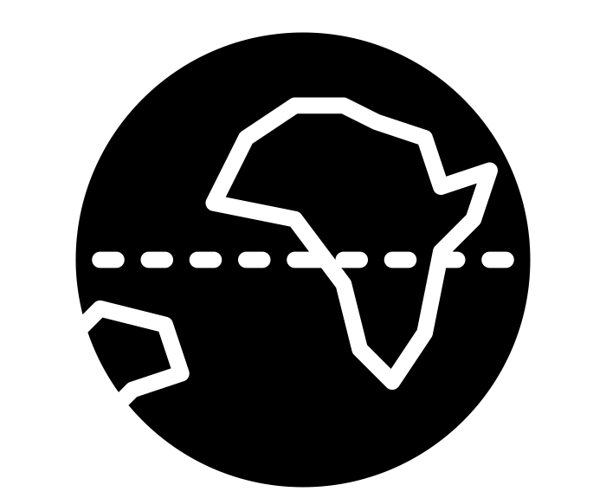 | The equator is the name for the widest part of our planet. Places at the equator are unusually very hot and dry. | 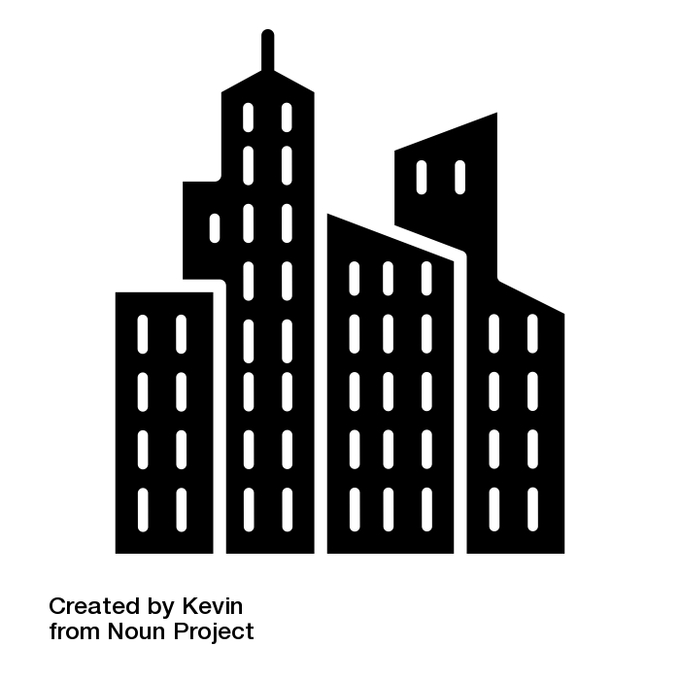 | Human geography describes the things in a place that are man made like building and transport systems. | 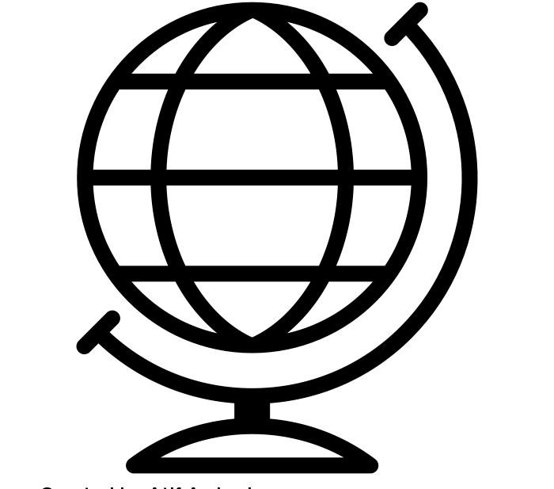 | Different areas of the world can grow more plants than others. A ‘hardiness zone’ shows where plants grow best. |  | Different foods need different things to grow. Some foods need hot and sunny conditions, others need wet conditions. | 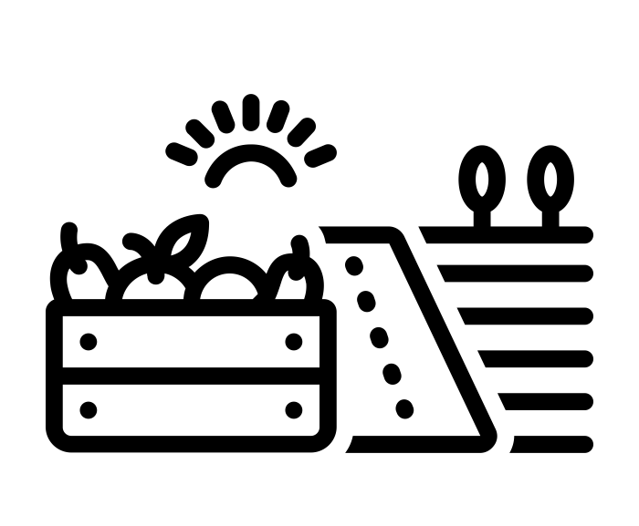 | We call things we grow for food ‘produce’. It is now often used to describe ‘fresh’ food. |  | Some foods, like fruits and chocolate, are grown thousands of miles away where it is hot all year round.
Key Vocabulary:  World  Pole  Equator |  | Key Vocabulary:  Feature  Physical  Human |  | Key Vocabulary:  Weather  Climate  Hardiness Zone |  | Key Vocabulary:  Origins  Map  Conditions |  | Key Vocabulary:  Seasons  Seasonal  Produce |  | Key Vocabulary:  Conclusion  Research  Prove

You will learn about human and physical geography again in Y4 when you will look at the water cycle. If you are interested in this learning you may want to be a transport planner.

