Year 2 – Uses of Everyday Materials SCIENCE KNOWLEDGE ORGANISER
Key Vocabulary |  | Key Knowledge
Material | The stuff that an object is made from – such as wood, metal, plastic or glass. | 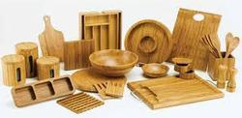  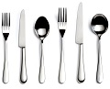  Properties of Materials  Wood: strong, stiff, hard, opaque, can be cut or carved into any shape.  Metal: strong, hard, waterproof, easy to wash, lasts for a long time.  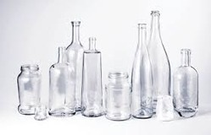  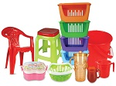  Plastic: waterproof, strong, can be stiff or flexible, smooth or rough.  Glass: waterproof, strong, transparent, smooth, stiff.  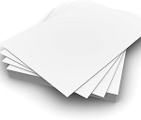  Paper: flexible, thin, lightweight, easy to cut or tear.    Objects are made from materials that have suitable properties for the purpose.  Fabric: flexible, soft, hard-wearing, can be stretchy, warm, absorbent.
Natural | Something from nature and not made by humans – such as wood, metal or rock.
Synthetic | Not natural, something that has been made by humans –such as paper, glass or plastic.
Property | This is what a material is like and how it behaves – hard, flexible, waterproof or stretchy.
Suitable | A suitable material would have the right properties for a particular use.
A scientist who developed a new material
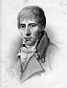  John McAdam | A Scottish engineer who developed a new way of building roads using crushed stones and tar. It was so successful that tarmac roads were built all over the world.
Key Questions
What are the properties of metal? |  | Strong, hard, waterproof, long-lasting, easy to wash. Can also be magnetic.
Which materials can be flexible? |  | Paper, fabric, plastic, rubber. Also, thin pieces of metal and even wood.
What is glass suitable for making? Why? |  | Windows, bottles or glasses because it is waterproof, transparent and strong.
How can you change the shape of some materials? |  | By twisting, squashing, bending or stretching.

