Year 5 - Unit 1 – The Anglo-Saxons
This unit follows on from your work on the Romans in year four. Later this year you will look at the Vikings, and compare them to the Romans and Anglo-Saxons.
What we are learning:  LO: To develop a chronologically secure knowledge and understanding of British, local and world history - historical enquiry |  | What we are learning:  LO: To develop a chronologically secure knowledge and understanding of British, local and world history - similarities and differences |  | What we are learning:  LO: To develop a chronologically secure knowledge and understanding of British, local and world history - cause and effect |  | What we are learning:  LO: To develop a chronologically secure knowledge and understanding of British, local and world history - change and continuity |  | What we are learning:  LO: To develop a chronologically secure knowledge and understanding of British, local and world history - historical significance |  | What we are learning:  LO: To develop a chronologically secure knowledge and understanding of British, local and world history - historical interpretations
  How we are learning/Small steps:  - I understand that events in time can be organised chronologically  - I can place key events onto a timeline |  | How we are learning/Small steps:  - I can describe life in Britain before Anglo Saxon arrival  - I can describe the Anglo Saxon push and pull factors |  | How we are learning/Small steps:  - I can use historical sources to present information about life in Britain during the Anglo Saxon Invasion  - I understand the effect of the invasion and how life changed for people as a result |  | How we are learning/Small steps:  - I can explore Anglo-Saxon art and culture  - I can explain how A-S art and culture is evident in modern life |  | How we are learning/Small steps:  - I can use historical sources to identify key elements of the Anglo-Saxon invasion  - I can explain why we still remember ‘Alfred the Great’ |  | How we are learning/Small steps:  - I can form conclusions, using my research to support my ideas  - I can ‘prove it’ - Britain went backwards thanks to the Saxons!
Key knowledge: |  | Key knowledge: |  | Key knowledge: |  | Key knowledge: |  | Key knowledge: |  | Key knowledge:
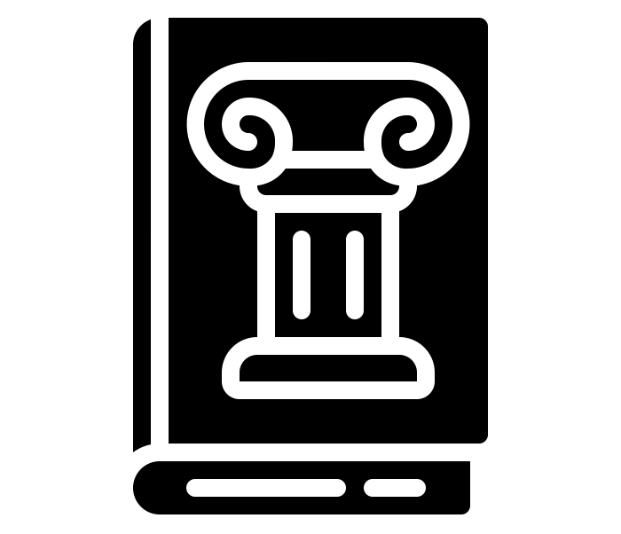 | A historian is someone who collects information about the past. | 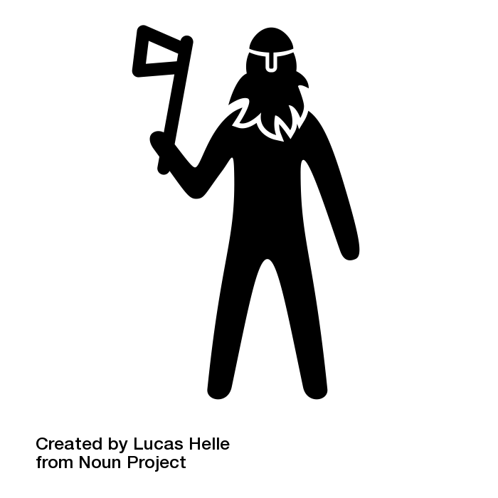 | The Celts were the people living in Britain at the time of the Anglo Saxons invasion. They were considered to be uncivilised. | 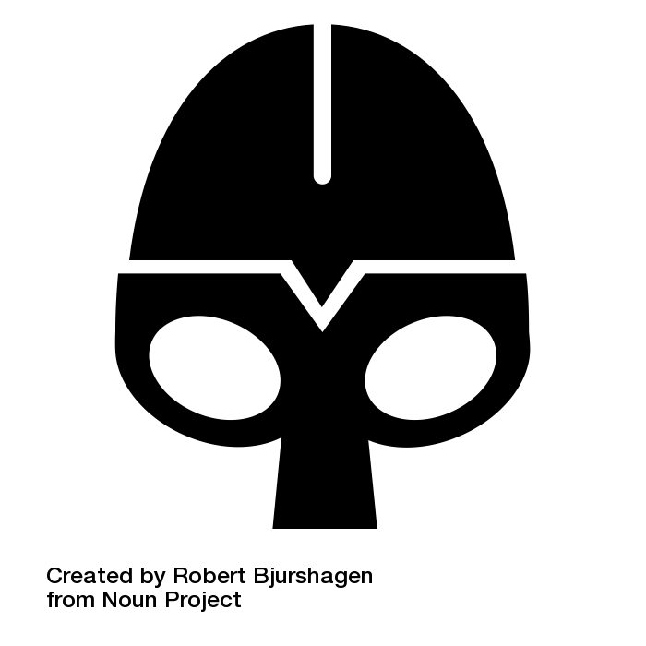 | The time of the Anglo-Saxons is known as the dark ages. It lasted about a thousand years and saw a decline in progress. | 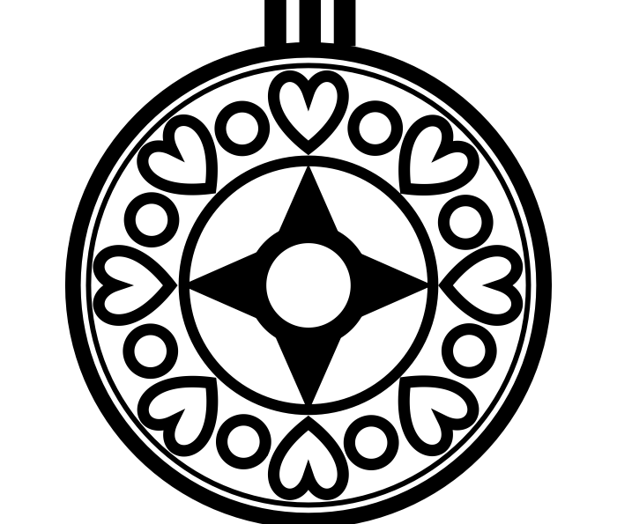 | Artefacts from Anglo Saxon times include beautiful and delicate jewellery including brooches. These were used to pin cloaks. |  | Sutton Hoo was discovered in 1938. It is a burial site from Anglo Saxon times and treasures were found inside a buried ship. |  | The Anglo-Saxon times are not as well documented as the Roman history period, suggesting that there were not as many developments during this time.
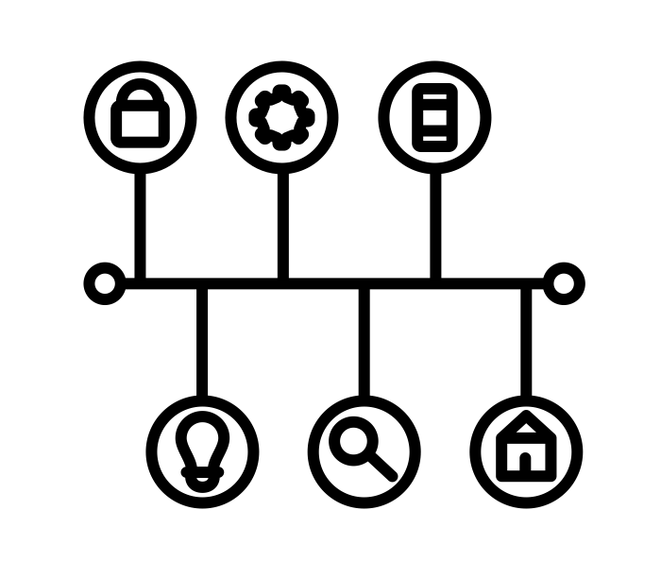 | Chronology means putting things in time order, from oldest to newest. | 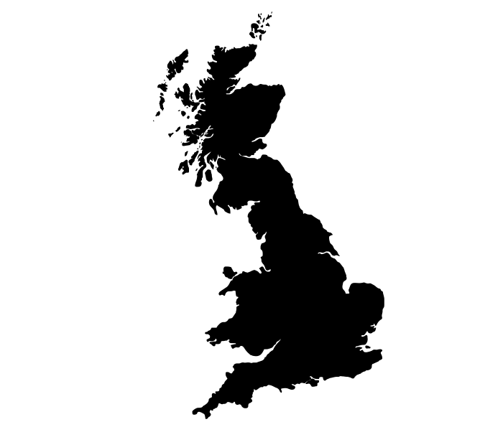 | Mercia was an area of Britain in Anglo Saxon times. It is now known as the Midlands. |  | The heptarchy was the combined name of the seven kingdoms of Anglo Saxon England. | 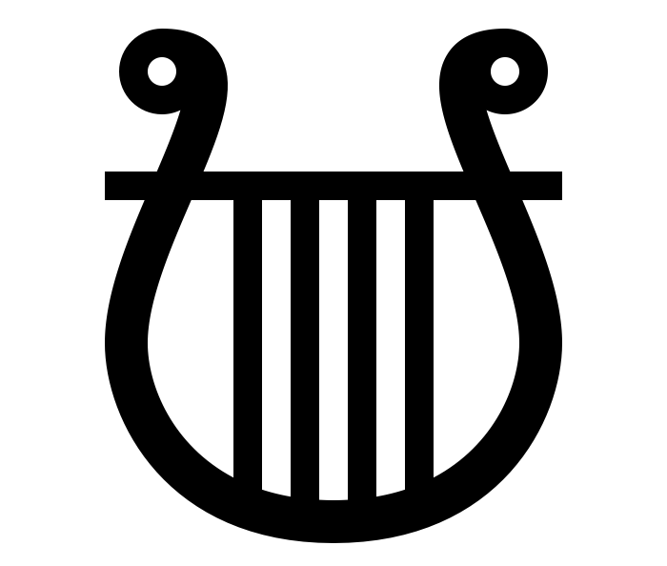 | The lyre was an instrument introduced into Britain by the Anglo Saxons. |  | Kingdoms were how England was divided up in Anglo Saxon times. Each kingdom was ruled by a king. | 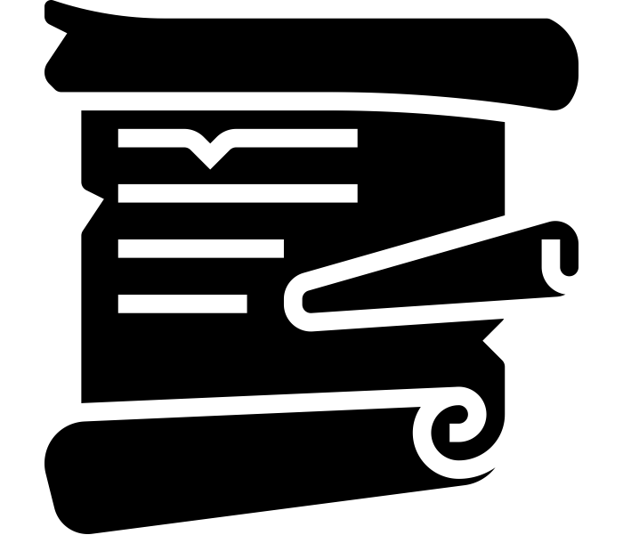 | Key figures were remembered for their inventions and ideas.
 | Events can be chronologically ordered on a timeline. |  | Wessex was an area of Britain in Anglo Saxon times. It was located in the south of England. | 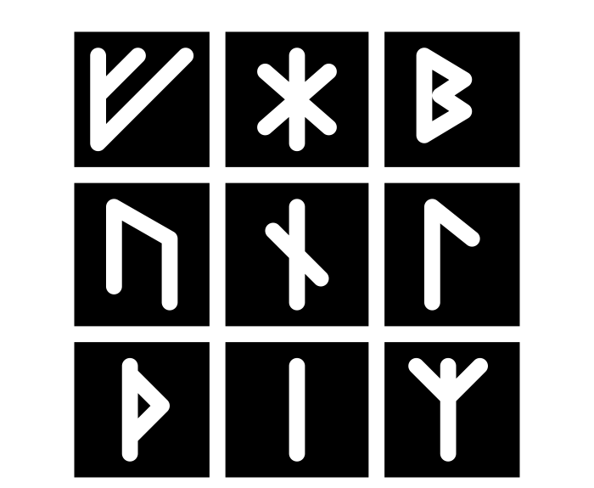 | Futhorc or Futhark are ‘runes’ or the alphabet used by the Anglo Saxons. | 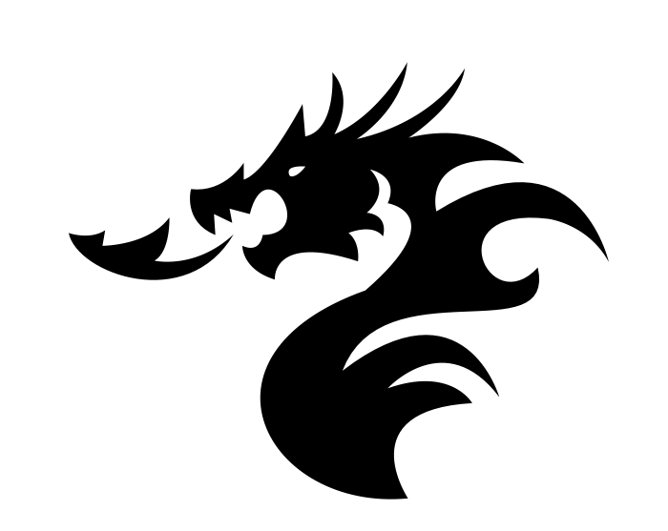 | Beowulf is a famous poem describing a warrior's quest to slay a dragon. |  | King Alfred is credited for ensuring the written history of his times were kept. He also created the first ‘Royal Navy’. |  | There were many beautiful things created by artists, writers and poems. The Anglo Saxons loved stories and music.
Key Vocabulary:  Historian  Chronology  Timeline |  | Key Vocabulary:  Celts  Mercia  Wessex |  | Key Vocabulary:  Dark Ages  Heptarchy  Futhorc |  | Key Vocabulary:  Brooch  Lyre  Beowulf |  | Key Vocabulary:  Sutton Hoo  Kingdom  Chronicle |  | Key Vocabulary:  Conclusion  Research  Prove

The viking unit later this year will be the last time you will learn about invaders and settlers at primary school. If you are interested in this learning you may want to be a heritage worker.

