Year 5 Forces SCIENCE KNOWLEDGE ORGANISER
Key Vocabulary |  | Key Knowledge
Forces | Pushes and pulls that can change the motion and shape of an object. | 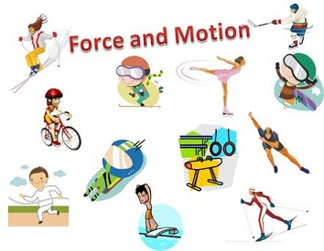  Forces can make an object stop or start to move and  forces can change an object’s speed, direction or shape.  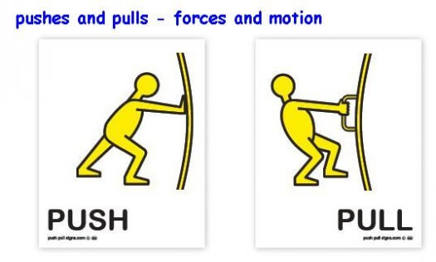  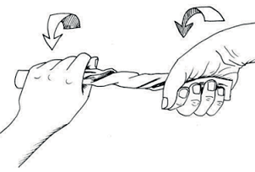  Forces are mostly pushes or pulls but they can sometimes be twists  TWIST  Forces can be Balanced (still or steady) or Unbalanced (causing a change)  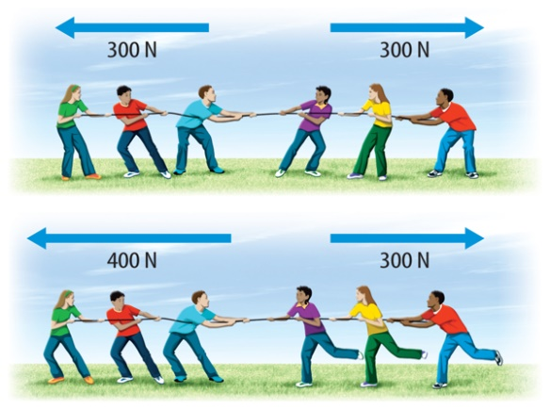  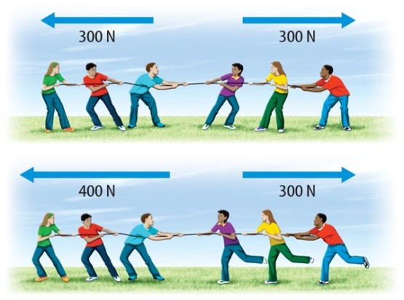  Weight is how strong gravity pulls an object down (N).  Mass is how much matter an object is made of (kg).  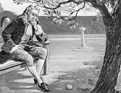  Isaac Newton was a British  scientist who is famous for  his theories about gravity  and three laws of motion.  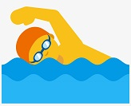  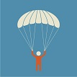  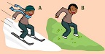  Air resistance and water resistance  are examples of friction, which acts  between moving surfaces or objects.  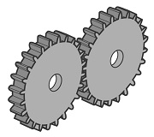  Mechanisms are parts in a machine that use forces to make tasks easier to do.  Gears change the speed, force  or direction of movement.  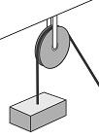  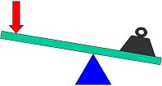  Levers and pulleys both reduce the forces needed to lift a load.
Balanced forces | When opposing forces are equal so an object remains still or steady.
Gravity | A pulling force exerted by one object on another object.
Mass | A measure of how much matter or stuff that an object is made of.
Weight | A measure of the force of gravity that pulls on an object.
Friction | A pushing force resisting an object when it moves over another object.
Air resistance | Friction caused by air pushing against a moving object.
Water  resistance | Friction caused by water pushing against a moving object.
Streamlined | When an object is shaped to reduce the effect of air or water resistance.
Mechanism | Parts in a machine that work together to reduce the effort needed.
Key questions
Why is gravity stronger on Earth than the Moon?
The greater the mass, the greater the gravity.
What happens if two opposing forces are unbalanced? There will be a change in the speed, direction or shape of an object.
Name three forces that can slow a moving object? Air resistance, water resistance and friction.

