Year 1 – Everyday Materials SCIENCE KNOWLEDGE ORGANISER
Key Vocabulary |  | Key Knowledge
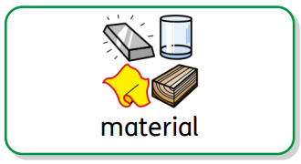 | What something is made from. | 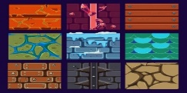  A material is what something is made from. Everything is made from a material and there are many different materials all around us:  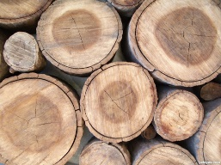  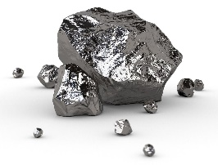  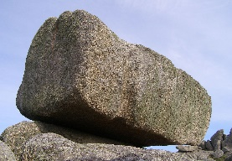  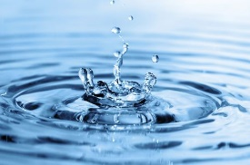  wood metal rock water  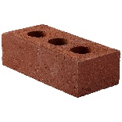  glass plastic fabric paper brick  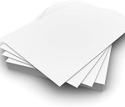  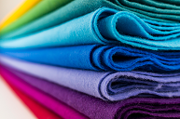  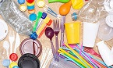  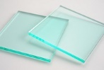  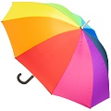  Certain materials are better than others for making objects, depending on their properties (the qualities and characteristics of something) and what the object is used for.
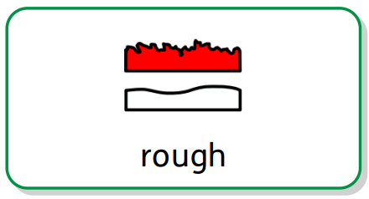 | Something that feels and looks uneven and bumpy.
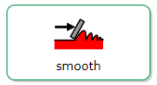 | Something that has no lumps or bumps.
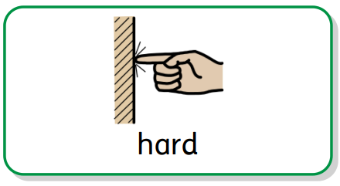 | Not easily broken or bent – it cannot be squashed easily.
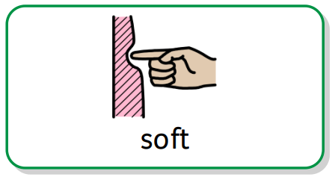 | Something that can easily be cut, easily be folded or its shape can be changed.
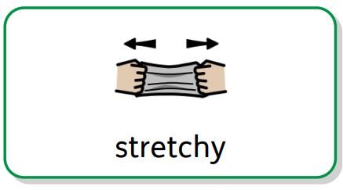 | Something that can be pulled to make it longer or wider.
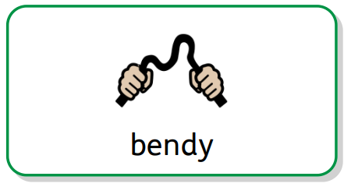 | Something that can easily be bent or folded.
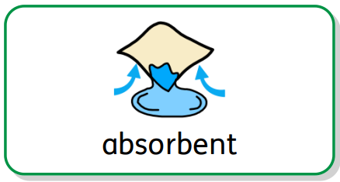 | Something that soaks up water.
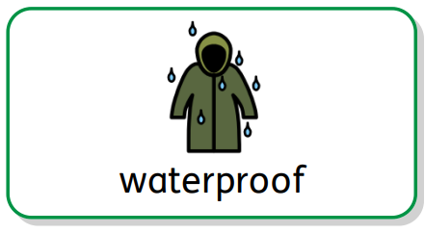 | Something that keeps water out – it stays dry.
Key Questions
Can you name some objects and the materials they are made from? |  | A pencil is made of wood, a jar is made of glass and a bottle is made of plastic etc.
Why is glass good for making windows? |  | It is waterproof, transparent (see-through) and quite hard. It cannot be bent or stretched.
Would jelly make a good table? |  | No, it is too soft and bendy. It would not be very useful.
What material should a boat be made from? |  | A material that is waterproof and hard e.g. metal, plastic or treated wood.

