Year 1 - Unit 1 – My Area, My School
This unit is your first geography unit. You have learned about Plymouth and our local area in Reception.
What we are learning:  LO: To use simple fieldwork and observational skills to study the geography of their school and its grounds and the key human and physical features of its surrounding environment |  | What we are learning:  LO: To use simple fieldwork and observational skills to study the geography of their school and its grounds and the key human and physical features of its surrounding environment |  | What we are learning:  LO: To use aerial photographs and plan perspectives to recognise landmarks and basic human and physical features; devise a simple map; and use and construct basic symbols in a key |  | What we are learning:  LO: To use aerial photographs and plan perspectives to recognise landmarks and basic human and physical features; devise a simple map; and use and construct basic symbols in a key |  | What we are learning:  LO:T0 use simple fieldwork and observational skills to study the geography of their school and its grounds and the key human and physical features of its surrounding environment |  | What we are learning:  LO: To use simple fieldwork and observational skills to study the geography of their school and its grounds and the key human and physical features of its surrounding environment
  How we are learning/Small steps:  - I can ask geographical questions about my locality  - I can use fieldwork and research to answer questions |  | How we are learning/Small steps:  - I can name different features of my locality  - I can say what each feature is for |  | How we are learning/Small steps:  - I know what a map is and what it does  - I can make a simple map of the KS1 building |  | How we are learning/Small steps:  - I know what a map is and what it does  - I can make a simple map of the whole school using aerial pictures |  | How we are learning/Small steps:  - I can use a simple map of Plymouth to find the school  - I can make a simple map to show features in our local area, using symbols and a key |  | How we are learning/Small steps:  - I can form conclusions, using my research to support my ideas  - I can ‘prove it’ - Maps are monotonous!
Key knowledge: |  | Key knowledge: |  | Key knowledge: |  | Key knowledge: |  | Key knowledge: |  | Key knowledge:
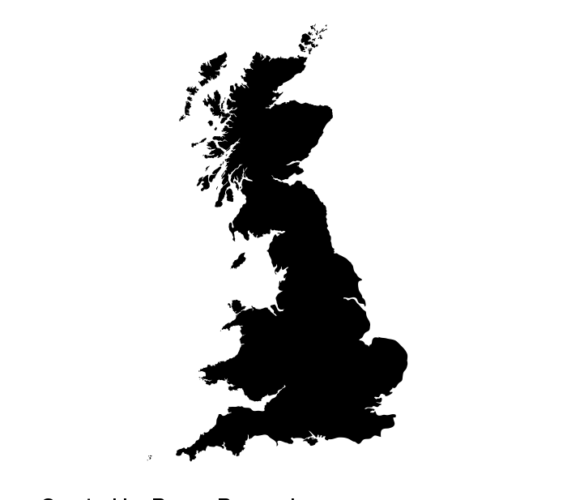 | We live in Britain. This is our country. We live in the South West of the country. | 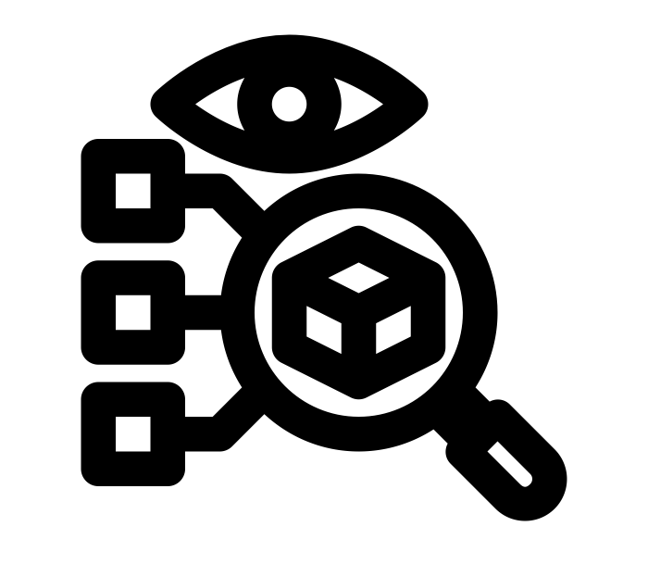 | A feature is a part of a place. It can be something large or small. | 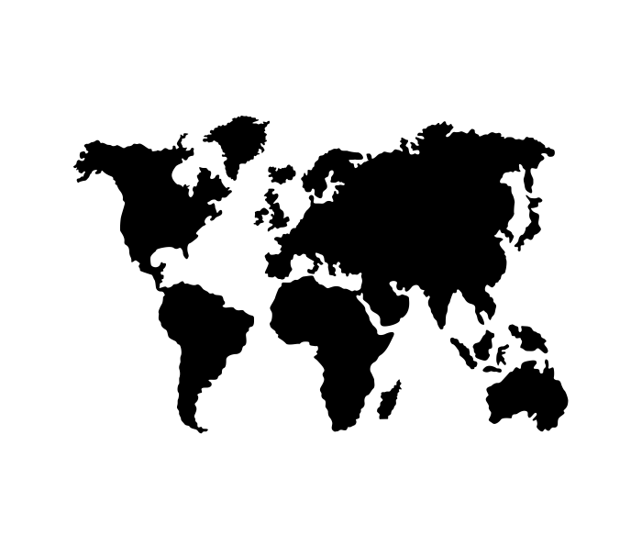 | A map shows where places are. They can be of large places like the world or small places like a town. | 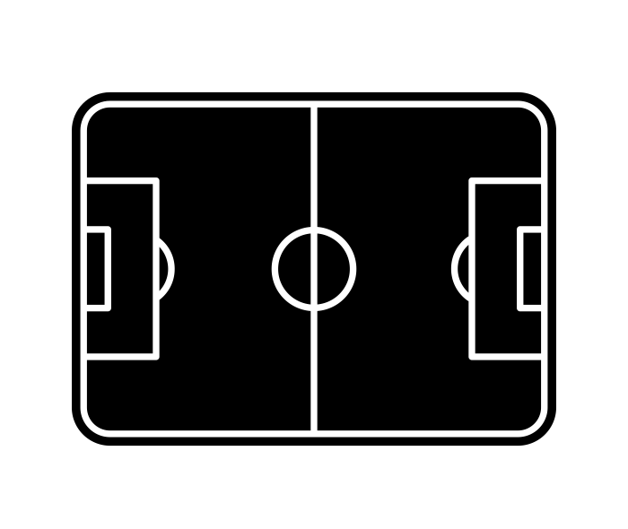 | An aerial view is what something looks like from the sky/above. | 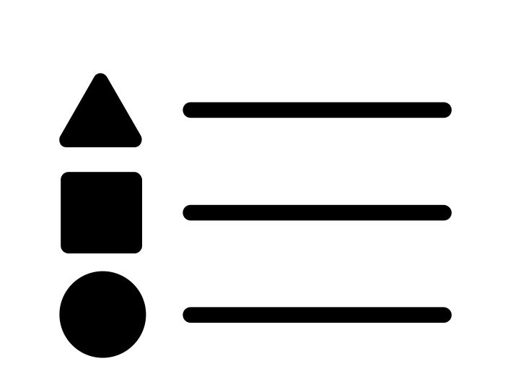 | A key shows how to understand symbols used on a map. |  | You can make maps about almost anything. They may even show where to find treasure!
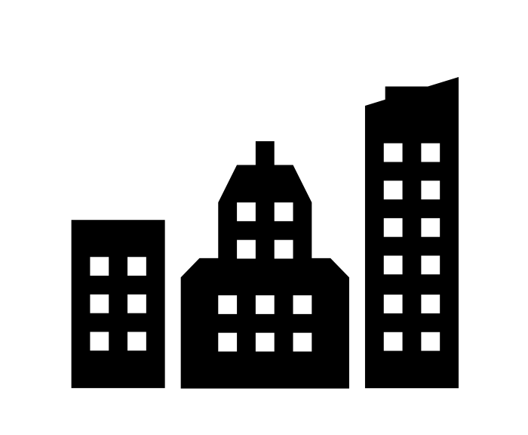 | We live in a city called Plymouth. Plymouth is in a county called Devon. | 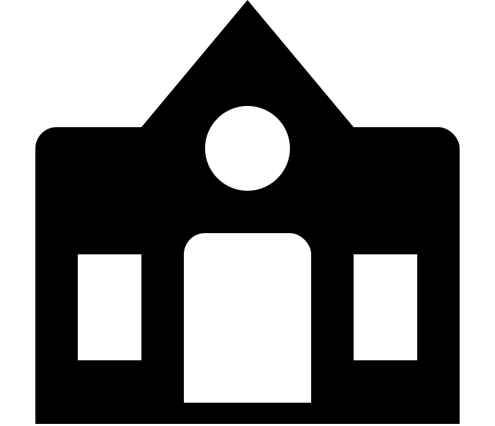 | Human features are things that have been man made. | 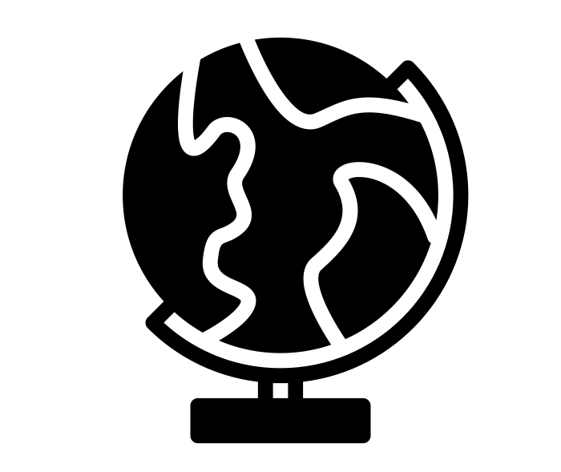 | A globe is a type of map. It shows the world as a sphere. | 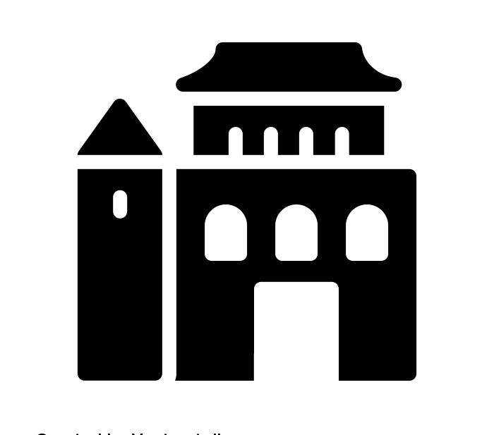 | A landmark is a memorable place. Landmarks help you to know where you are. | 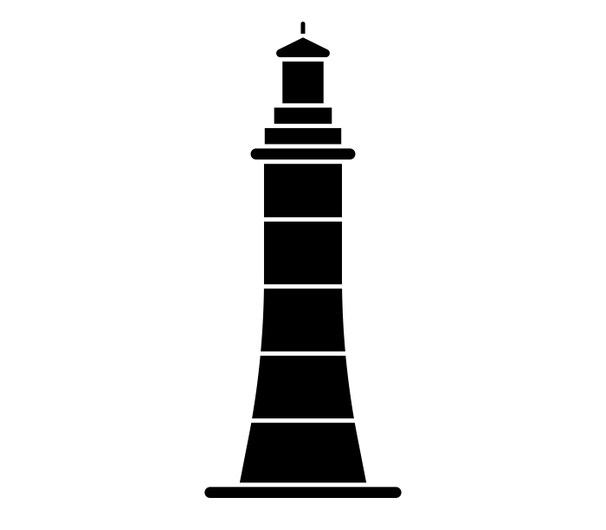 | Plymouth is our city. A feature/landmark of Plymouth is Smeaton’s Tower. |  | Maps show us interesting places to visit and interesting things to see.
 | Our locality is Stonehouse. Our school is on High Street in Stonehouse. | 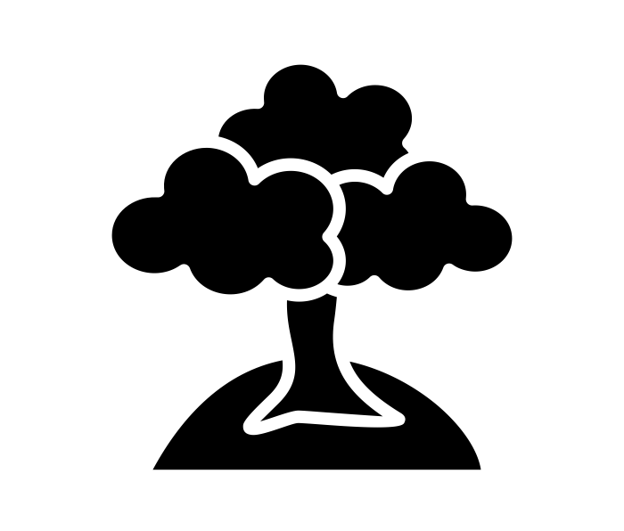 | Physical features are the natural things you can see around you. | 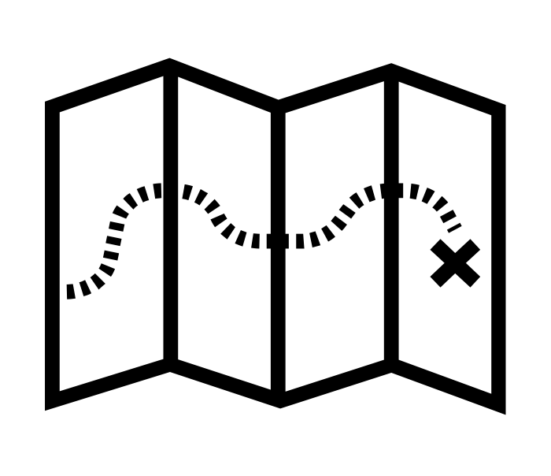 | A map can help us by showing us the way. This is called giving directions. | 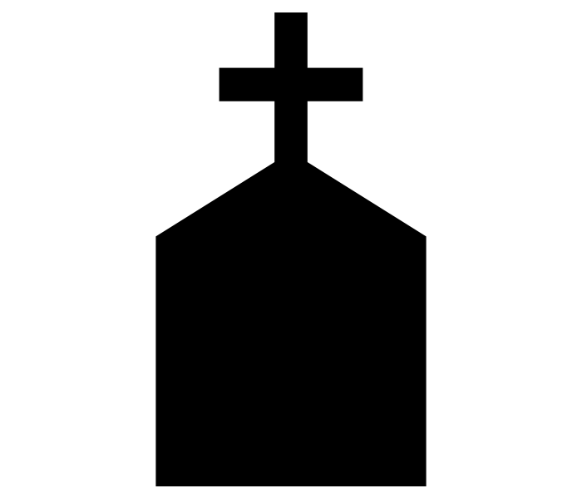 | Symbols on maps make it easy to find features such as churches and rivers. |  | Devenport is the part of Plymouth we live in. |  | Maps can help us explore our local area and get to know it better.
Key Vocabulary:  Country  County  Locality |  | Key Vocabulary:  Feature  Human  Physical |  | Key Vocabulary:  Map  Globe  Directions |  | Key Vocabulary:  Aerial View  Landmark  Symbols |  | Key Vocabulary:  Key  Plymouth  Devenport |  | Key Vocabulary:  Conclusion  Research  Prove

You will learn about the local area again in Y2. If you are interested in this learning you may want to be a geography teacher.

