Year 6 – Light SCIENCE KNOWLEDGE ORGANISER
Key Vocabulary |  |  | Key Knowledge
Light | A form of energy that travels in a wave from a source. |  | 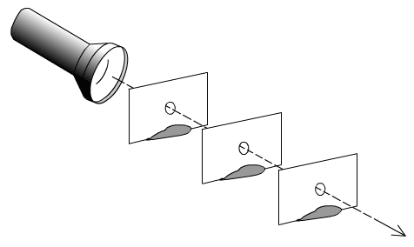  We need light to be able to see things. Light waves travel from  a source in straight lines. These lines are called rays of light.  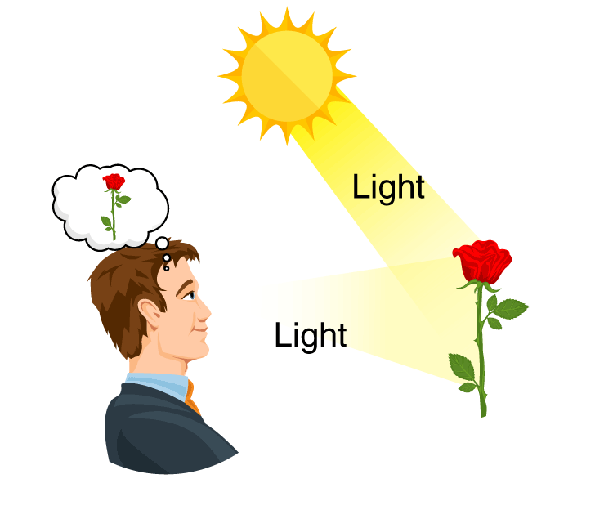  Light from a source travels in straight lines and hits objects.  These light rays are reflected off the objects in straight lines  and enter our eyes, enabling us to see the objects.  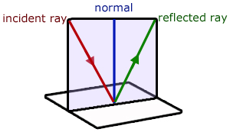  The angle of a ray of light which hits a flat surface (incident ray) is always equal to the angle of the reflected ray of light. This is called the Law of Reflection.  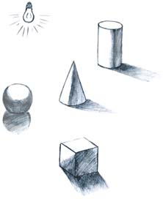  A shadow is always the same shape as the object that casts it.  When an opaque object is in a path of light, it blocks the light  that hits it but the rest of the light continues to travel past.  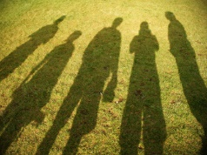  A shadow is larger when the object is closer to the light source  because more light is blocked. Shadows can also be longer or  shorter depending on the angle of the light source.  Isaac Newton shone a light through a prism which separated  visible light into the colours of the spectrum (like a rainbow).
Light  Source | An object that makes its own light.
Reflection | When light bounces off a surface and changes direction.
Incident ray | A ray of light that hits a surface.
Reflected ray | A ray of light that bounces back after hitting a surface.
Shadow | An area of darkness where light has been blocked.
Opaque | Objects that do not let any light travel through them.
Translucent | Objects that let some light through but scatter the light.
Transparent | Objects that let light travel through easily (see-through).
Refraction | Light bending when it passes from one medium to another.
Visible spectrum | Light that is visible to the human eye (white light).
Key Questions
How do light waves travel? |  | Light waves travel in straight lines from a source of light.
Which surfaces reflect light well? |  | Lighter coloured surfaces that are flat, smooth or shiny reflect light well.
How does light enable us to see? |  | Light travels from a source into our eyes or reflects off surfaces and enters our eyes.
What causes shadows to change? |  | When the distance or the angle between the object and the light source changes.
What are the colours of the spectrum? |  | Red, orange, yellow, green, blue, indigo and violet - these all merge into visible light

