Year 6 - Unit 1 – The Amazon
Your last place knowledge unit was in Y5 when you learned about Rivers.
What we are learning:  LO: To understand geographical similarities and differences through the study of human and physical geography of a region of South America |  | What we are learning:  LO: To understand geographical similarities and differences through the study of human and physical geography of a region of South America |  | What we are learning:  LO: To understand geographical similarities and differences through the study of human and physical geography of a region of South America |  | What we are learning:  LO: To understand geographical similarities and differences through the study of human and physical geography of a region of South America |  | What we are learning:  LO: To understand geographical similarities and differences through the study of human and physical geography of a region of South America |  | What we are learning:  LO: To understand geographical similarities and differences through the study of human and physical geography of a region of South America
  How we are learning/Small steps:  - I can ask geographical questions about a region  - I can use research to answer questions |  | How we are learning/Small steps:  - I can name the physical features of the Amazon Basin  - I can compare and contrast the physical features to those in my locality |  | How we are learning/Small steps:  - I can name the human features of the Amazon Basin  - I can compare and contrast the physical features to those in my locality |  | How we are learning/Small steps:  - I can name plant and animal species indigenous to the Amazon basin  - I can explain how the animals are adapted to their environment |  | How we are learning/Small steps:  - I know how culture and agriculture has affected the rainforest  - I can identify conservation methods used to protect the Amazon basin. |  | How we are learning/Small steps:  - I can form conclusions, using my learning to support my ideas  - I can ‘prove it’ - Rainforests rule for animals, but not humans.
Key knowledge: |  | Key knowledge: |  | Key knowledge: |  | Key knowledge: |  | Key knowledge: |  | Key knowledge:
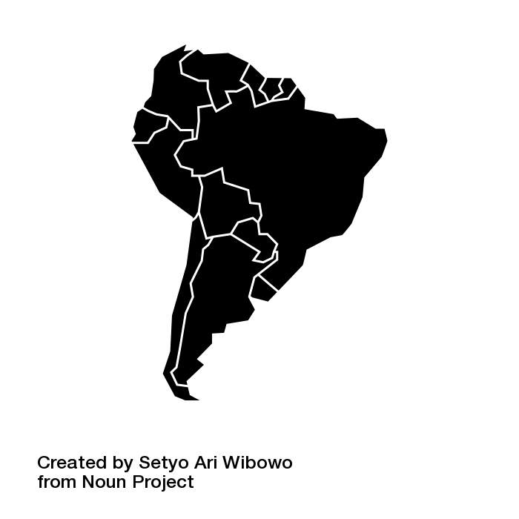 | The Amazon river runs through the continent of South America. It is one of the longest rivers in the world. A continent is a large land mass. | 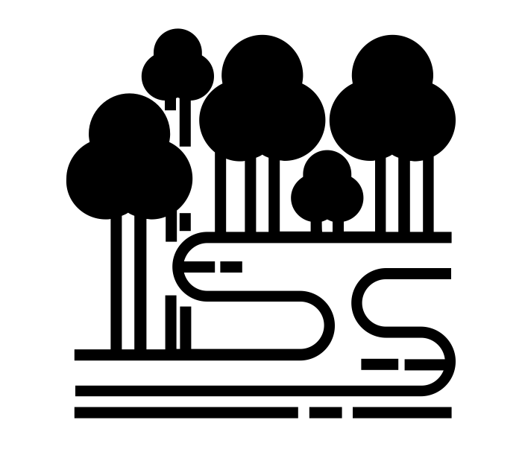 | The Amazon is a huge river surrounded by rainforest. This is a highly unique habitat; rainforests are hot, humid and rich with life. | 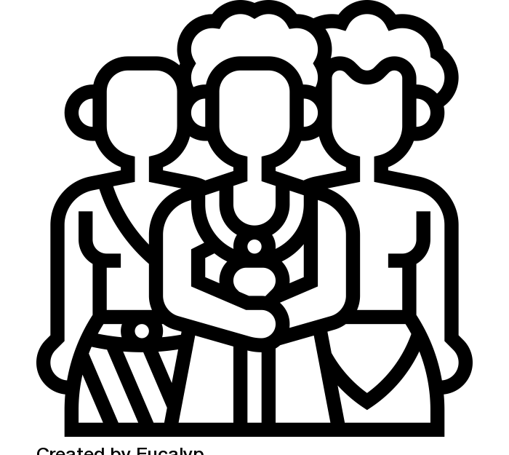 | The Amazon basin is home to people of many different nationalities. There are tribes deep in the jungle that have never been seen. |  | Lots of animals are indigenous to the rainforest meaning they have always lived in the rainforest and manage well in the habitat. | 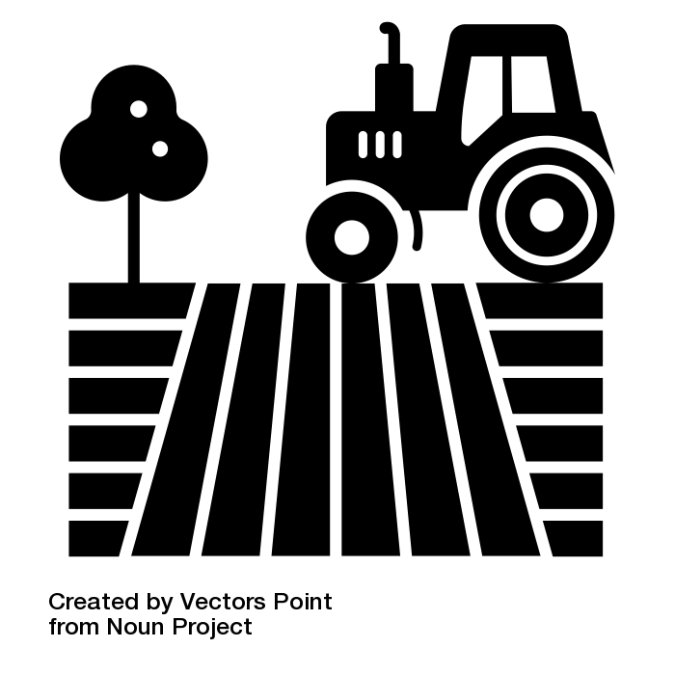 | Many of the surrounding areas of the Amazon have been cleared to raise cattle to supply restaurants and supermarkets with meat. |  | Humans use the Amazon for agriculture including growing soya beans and grazing cattle.
 | The region surrounding the Amazon is largely rainforest. It is an ecosystem rich with life. | 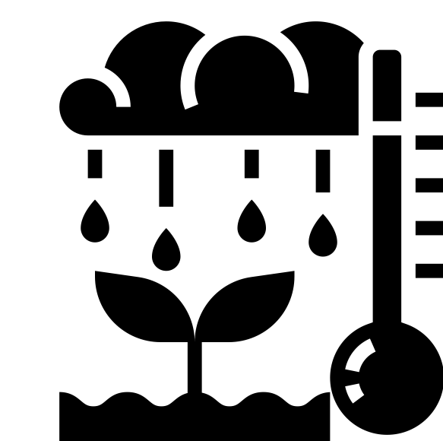 | The climate of a tropical rainforest is hot, humid, and rainy. Average monthly temperatures usually exceed 18°C. | 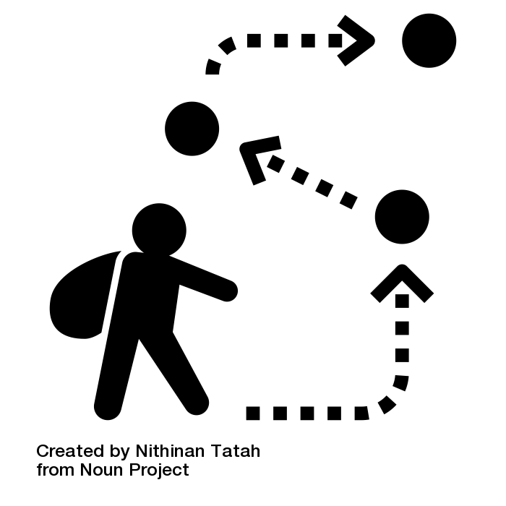 | Some of the indigenous people are semi nomadic - they move between settlements to hunt and collect food. |  | The majority of plants in the Amazon are trees. They form a canopy over the river and different species live in the different layers. |  | Trees have been removed from the forest - this is called deforestation.It means loss of habitat and the extinction of animals. |  | Some tribes are so at home in the forest, they have never really been seen by people.
 | The Amazon stretches through nine South American countries. | 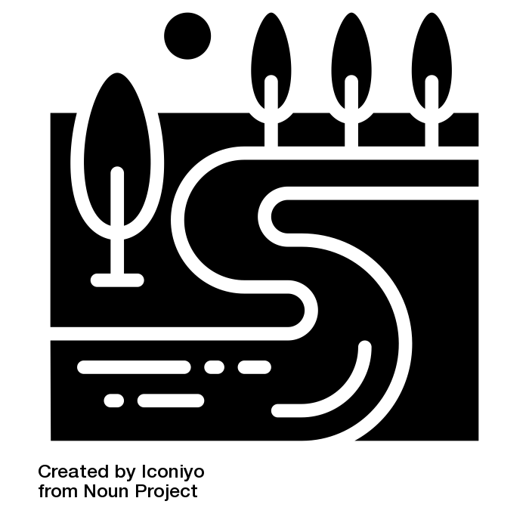 | A basin is an area of land around a river. It includes flood plains, lowlands and swamps. |  | Recently, cities have developed near the Amazon. Agricultural workers live in the cities - they travel to work on the land. | 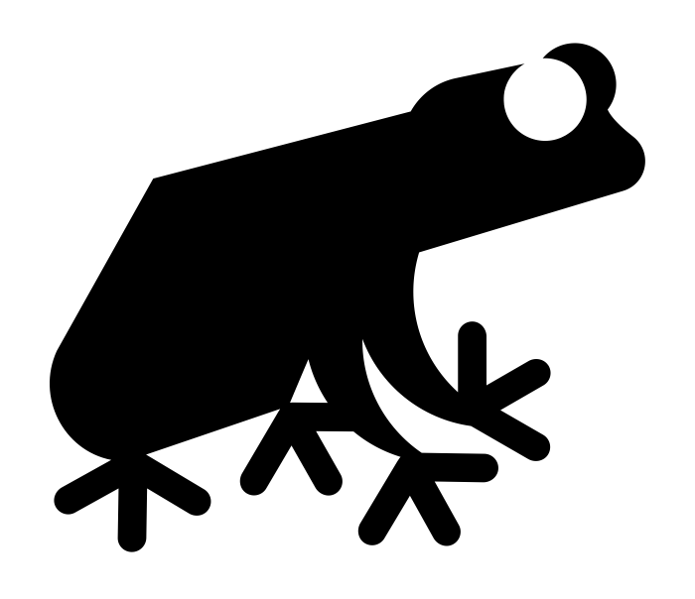 | Animals have adapted to live well in the rainforest. They may have developed camouflage or become poisonous over time. |  | Deforestation also causes climate change. This is because the loss of trees means rising CO2 levels. |  | The impact of humans living in the forest is impacting the climate. Animals are being harmed - some have gone extinct as a result of humans.
Key Vocabulary:  Continent  Region  Countries |  | Key Vocabulary:  Rainforest  Climate  Basin |  | Key Vocabulary:  Tribes  Semi Nomadic  Agriculture |  | Key Vocabulary:  Indigenous  Canopy layers  Adaptation |  | Key Vocabulary:  Agriculture  Deforestation  Climate change |  | Key Vocabulary:  Conclusion  Research  Prove

This is the last time at primary school that you will explore places in Geography. If this unit interests you, you may want to pursue a career as a climate scientist.

